ITA0305- Mobile Computing
LAB EXPERIMENT
Name: G.Ganesh
Reg NO:192373008

13. Design an infographic in Figma comparing mobile communication and mobile computing
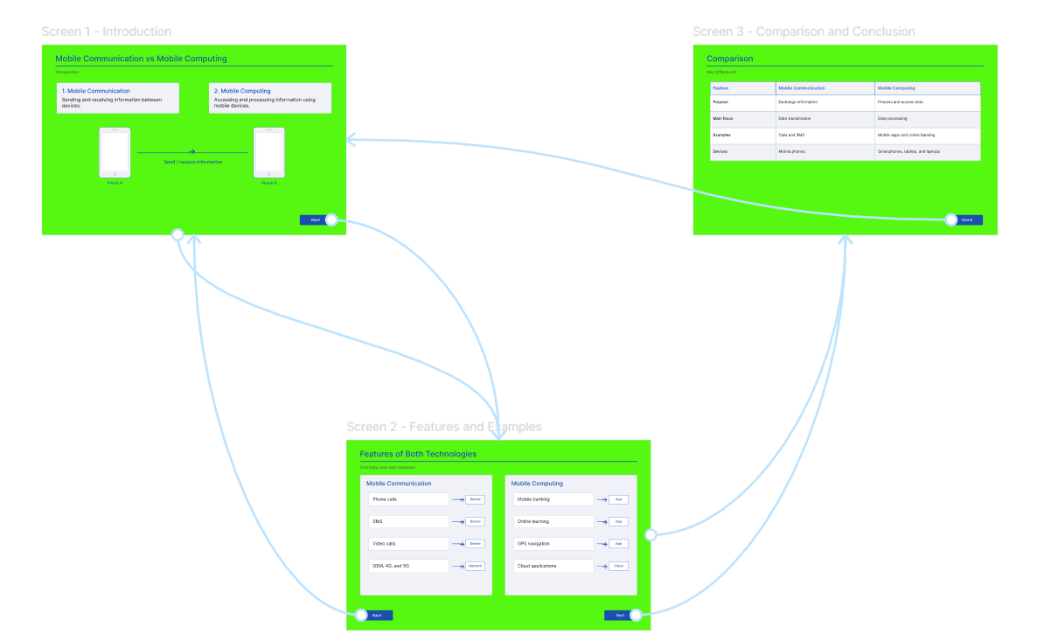

https://www.figma.com/design/m7lfknoBL4EAGyF2CBzOU2/program13?t=a43dOu4p2kOfscwt-0

